Q2

a. ssh - Connect to a remove host using the ssh protocol

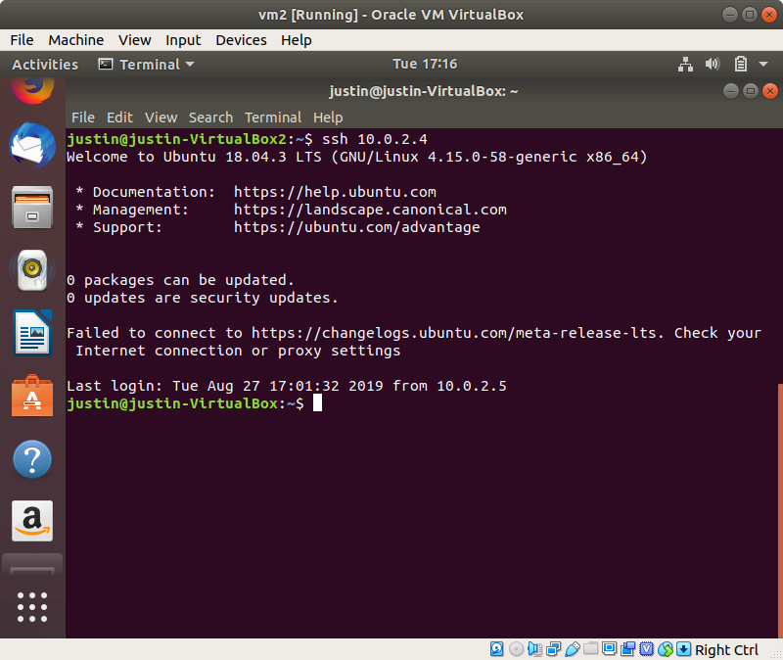t

b. ssh-keygen - create a public-private key pair for ssh authentication

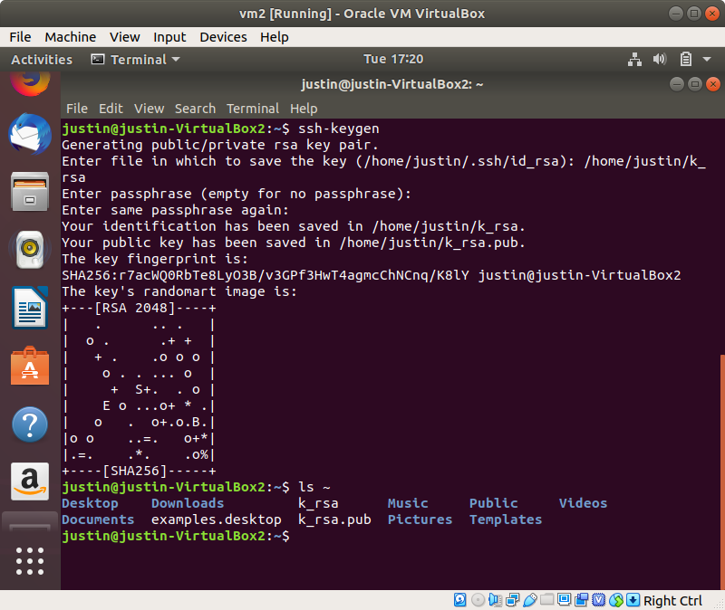

c. scp - copy files from remote to local, and vice versa

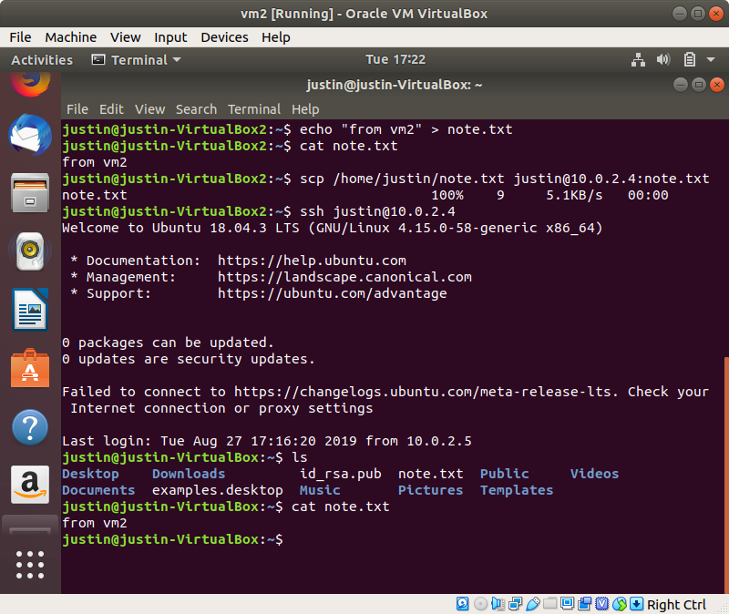

d. history - display previously inputted commands

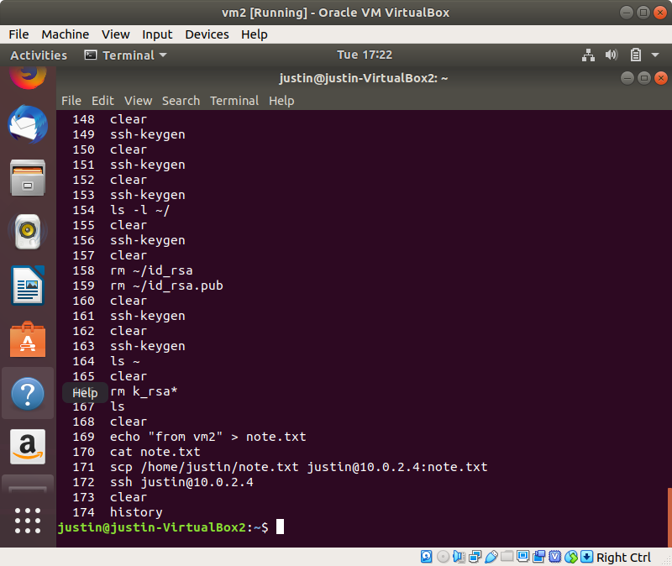

e. sudo - Execute commands at elevated privilege user

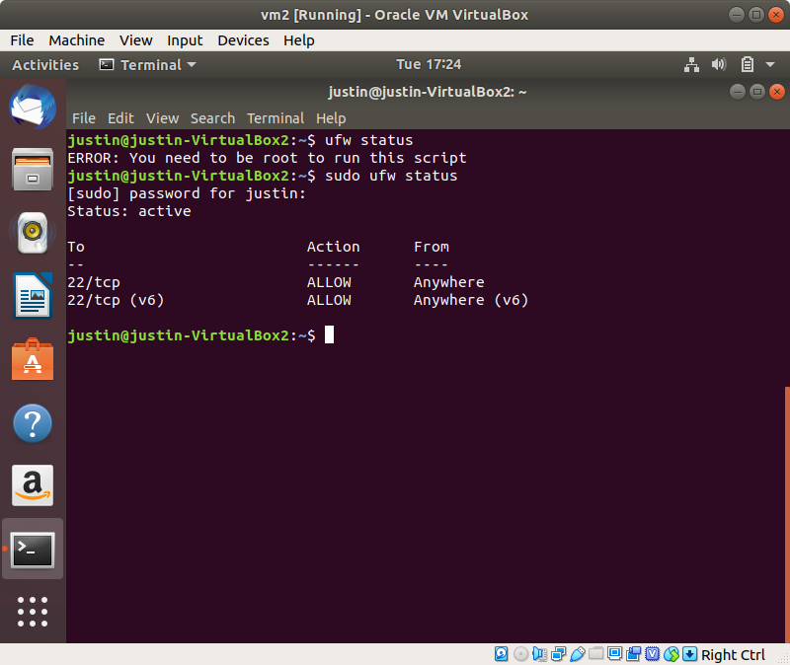

f. ip - display network adapter interface settings (ip masks, addresses - ip and MAC, etc)

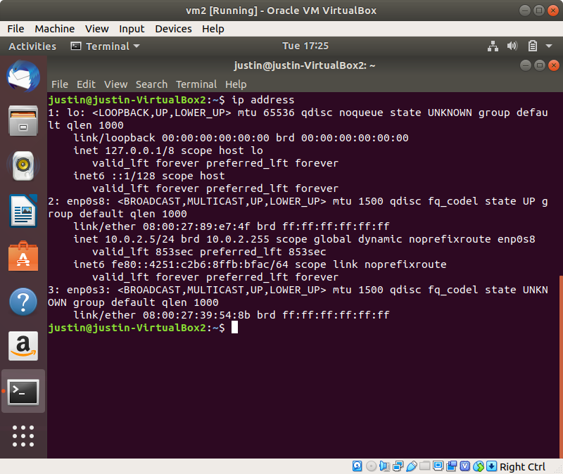

g. dd - copy bytes files from specified input to output. Shows performance.

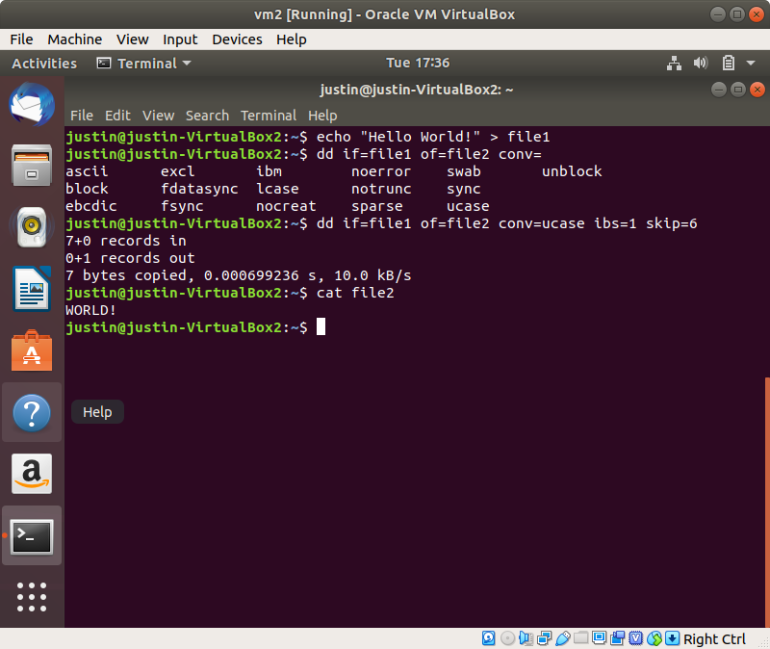

h. fdisk - Manage the partition of a disk device

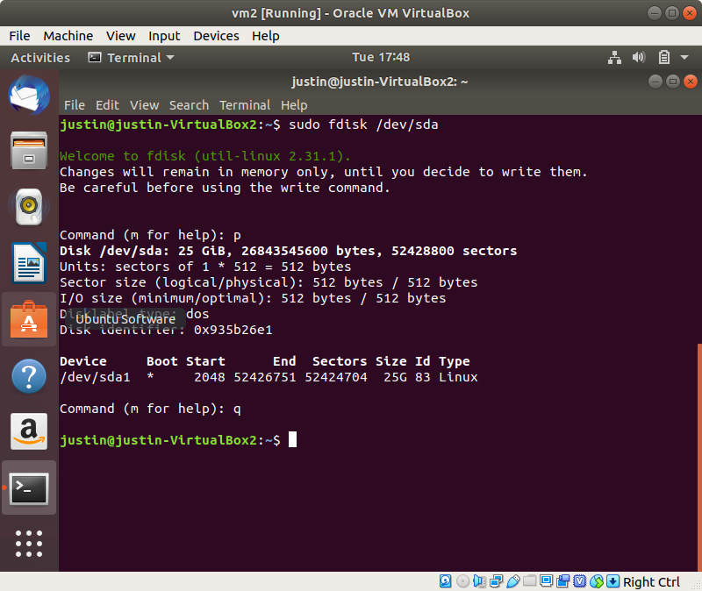

i. apt - the command line interface for the package manager in ubuntu. Use to install and remove packages.

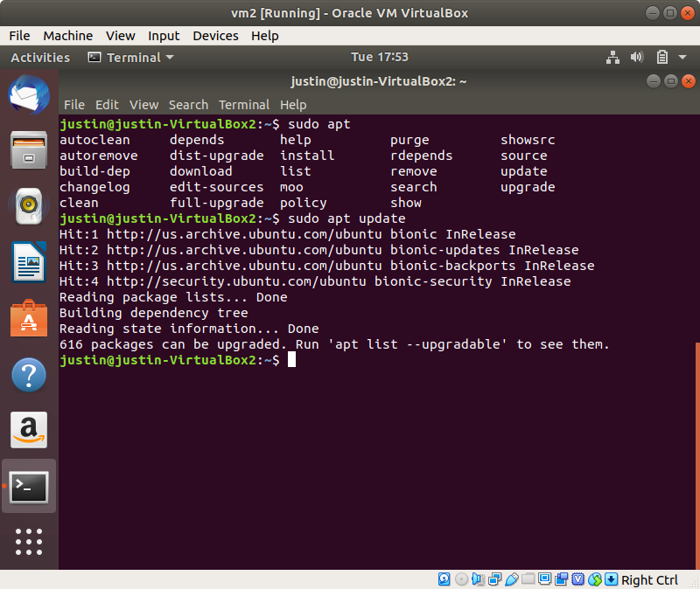

j. vi - lightweight text editor

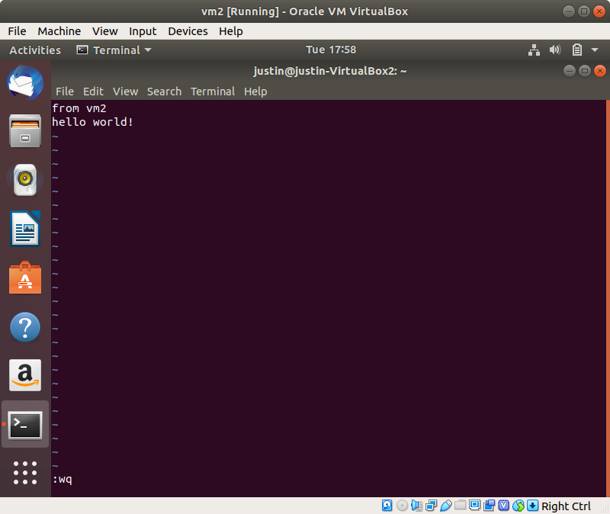

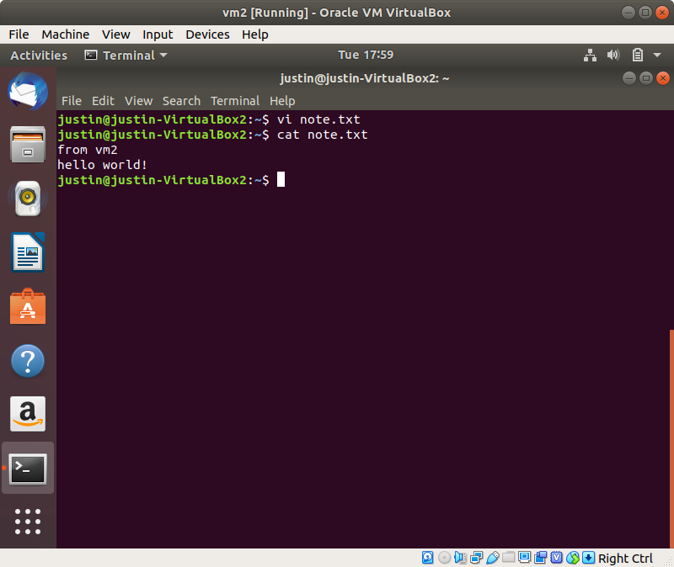

k. time - show the execution time of a program

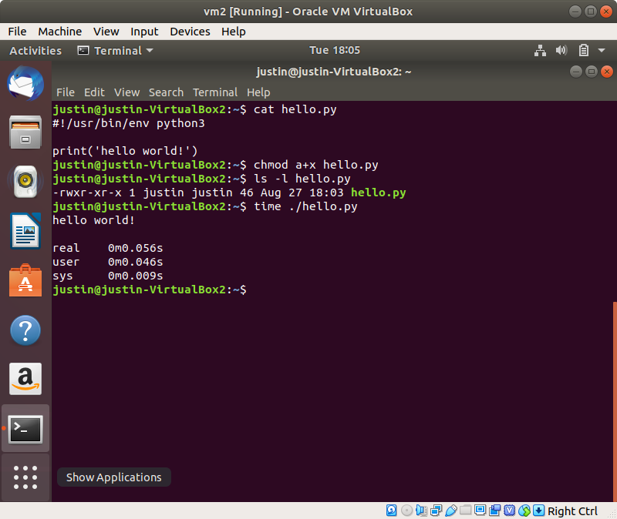

l. tar - archive and compress files and directories, and also extracts created archives

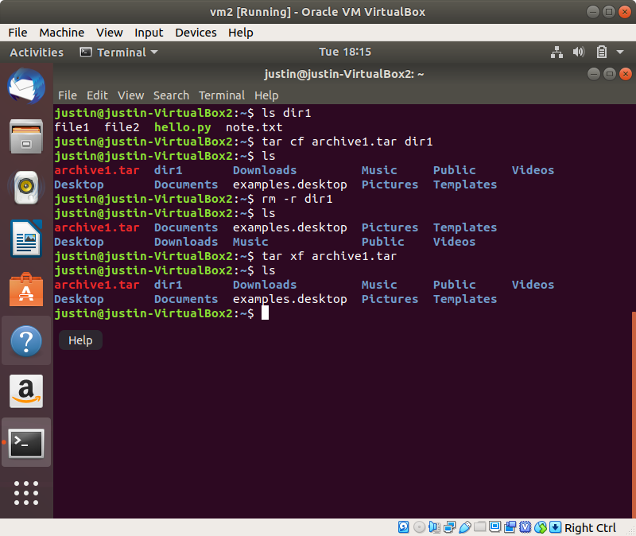

m. cat - print contents of file to standard output

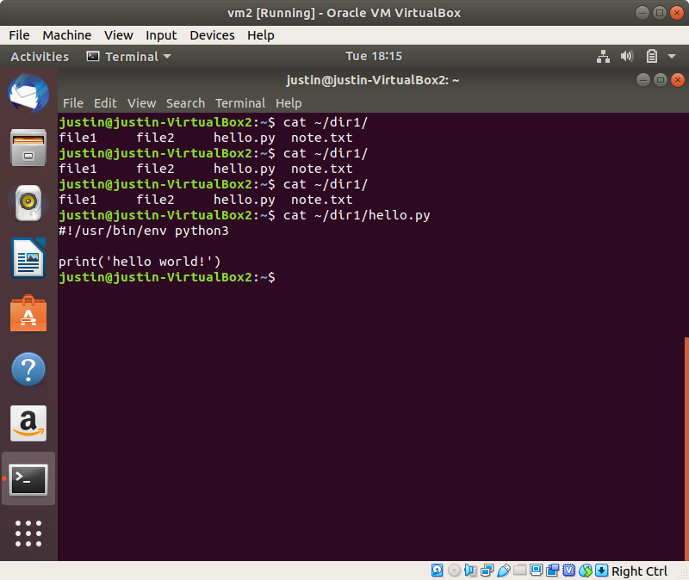

n. watch - periodically execute a command in the shell, while displaying the output on every execution.

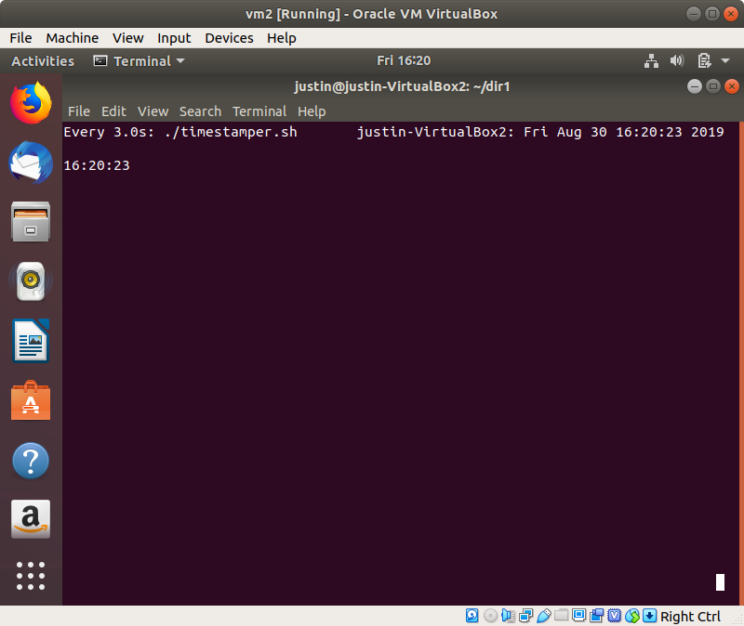

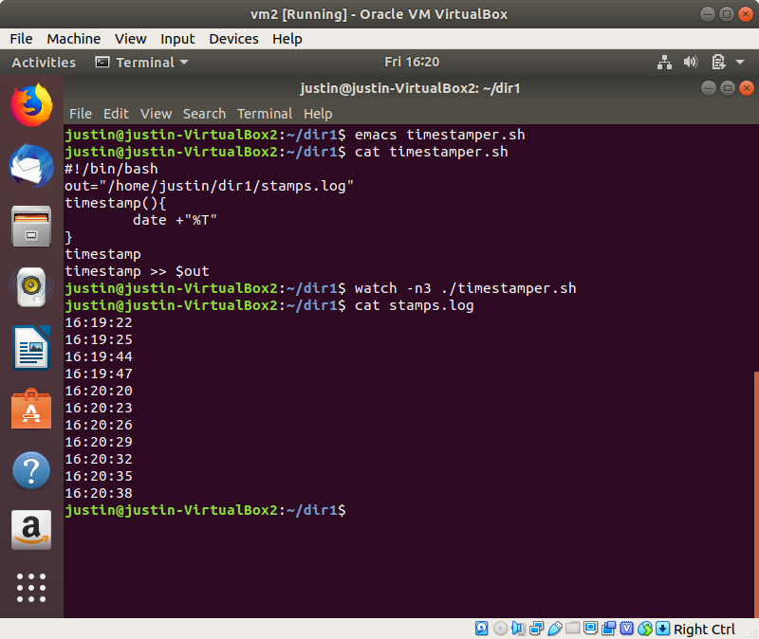

o. ps - display current running processes

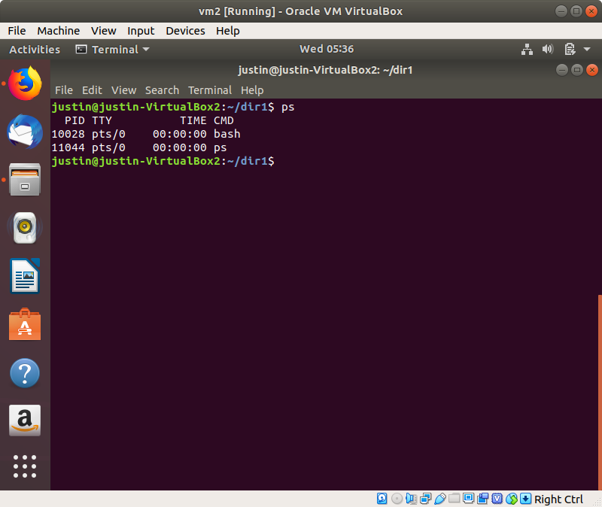

p. top - Display all running linux processes, dynamically

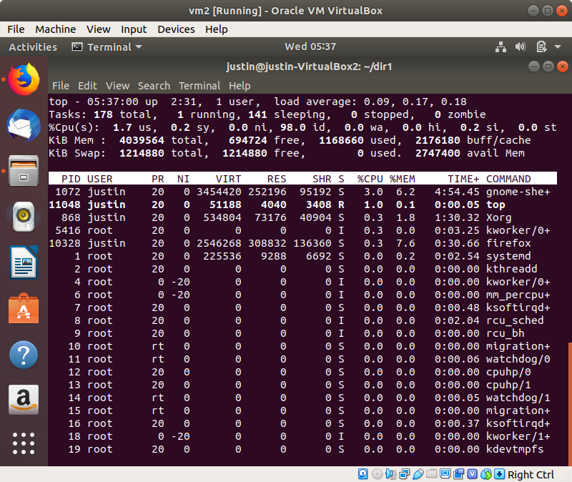

q. htop - A “prettier” top, with more functionalities (e.g. select multiple processes at once)

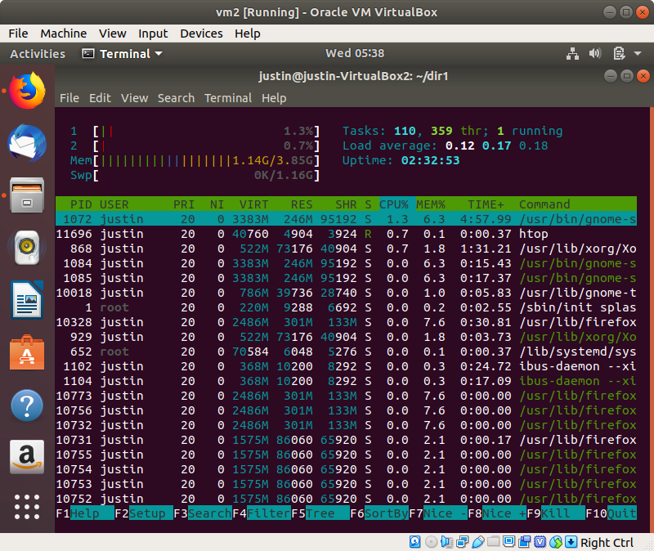

r. gcc - GNU C compiler

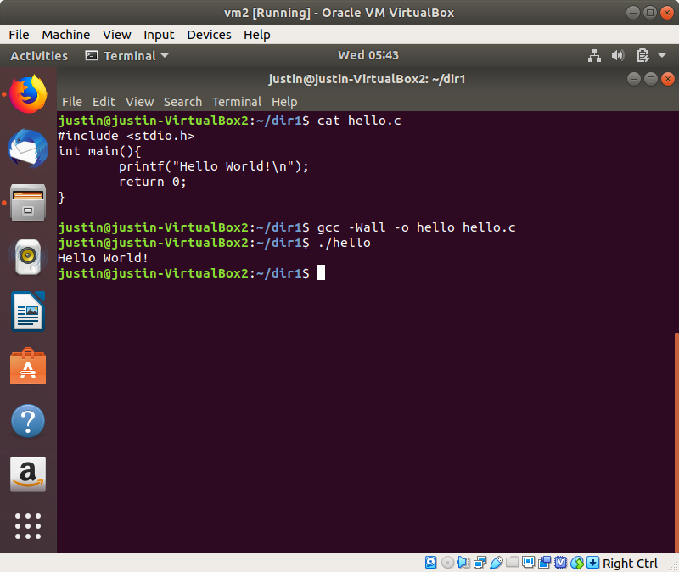

s. tail - print the last lines of a file to stdout

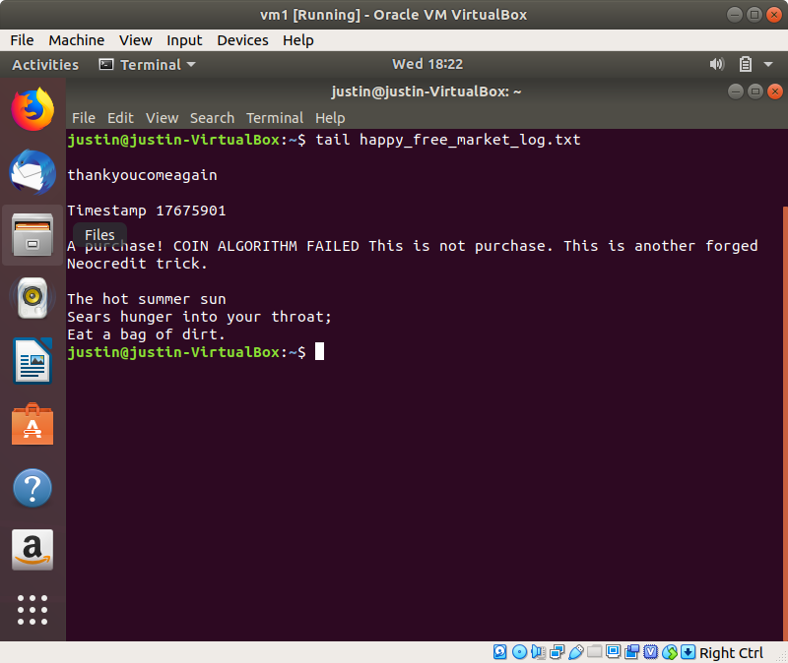

t. grep - a text filter program that finds matches from input files using regex.

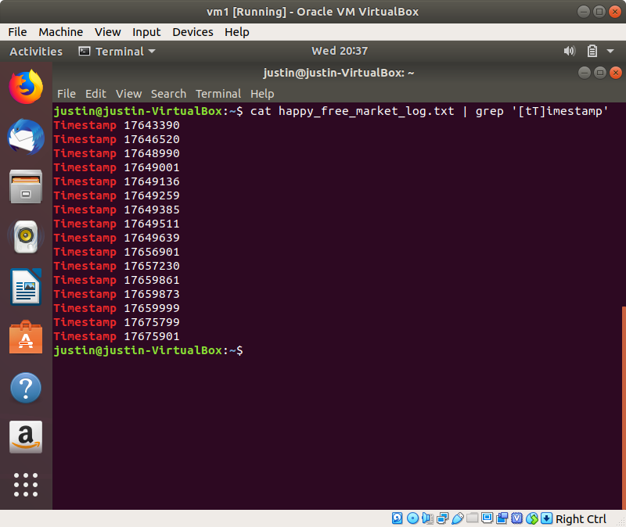

u. kill - terminate a running process

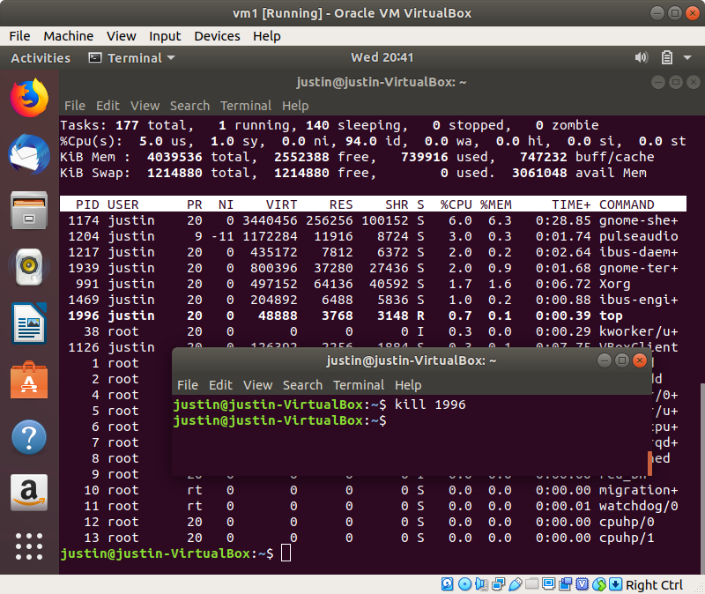

v. killall - terminate all processes with the provided program name

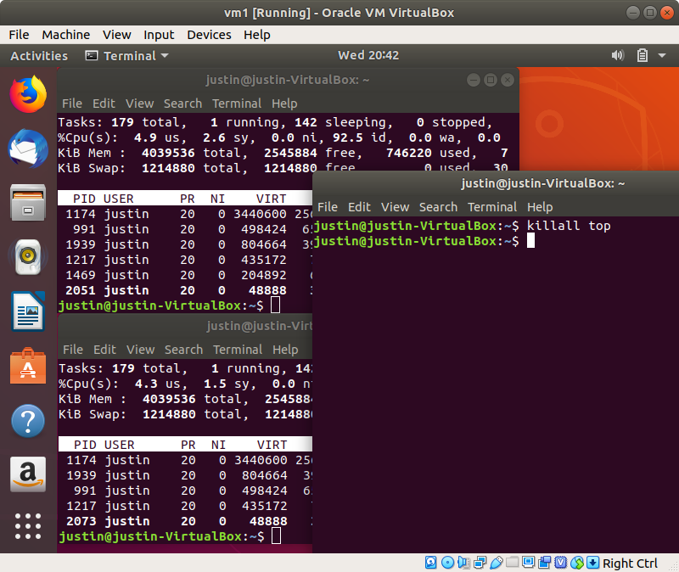

w. du - Estimate the file sizes in the given directory

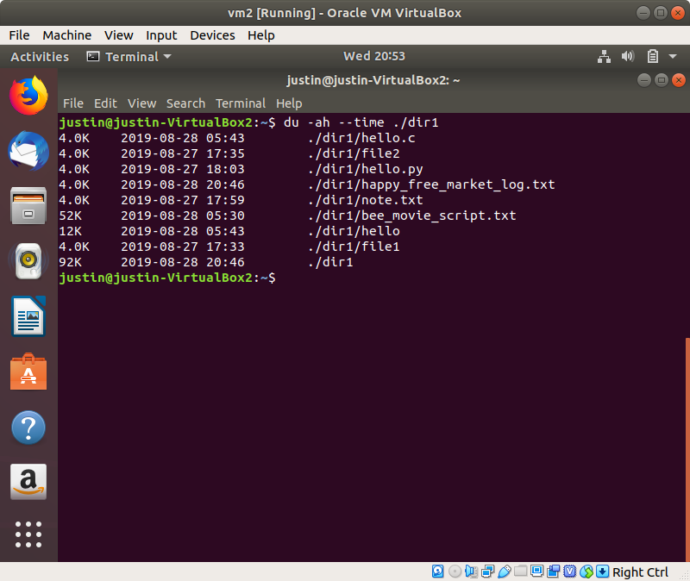

x. df - Display the filesystem usage and disk availability

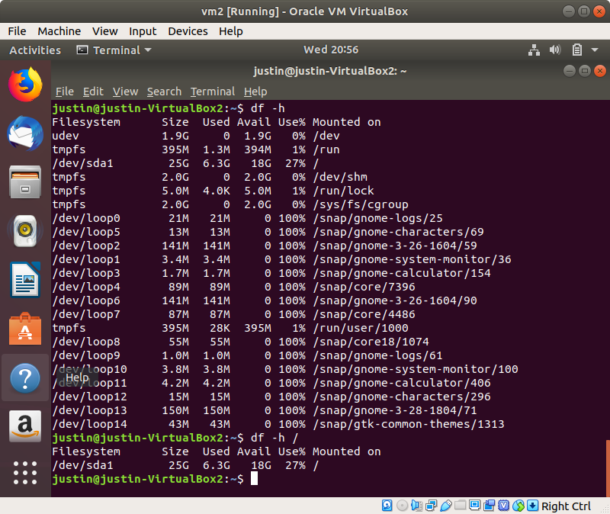

y. screen - run processes in the background, with command logging functionalities

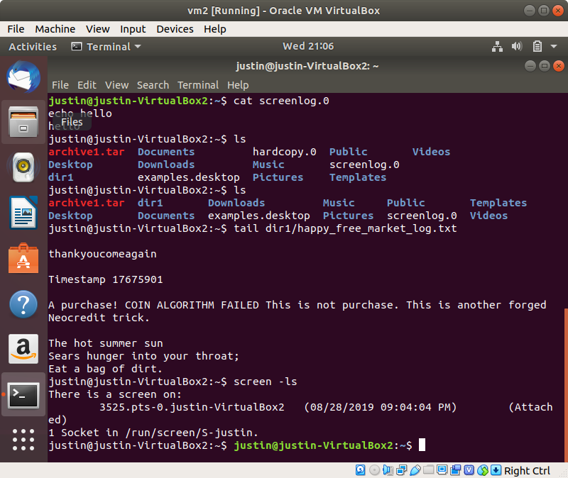z. vim - Text editor, VI iMproved

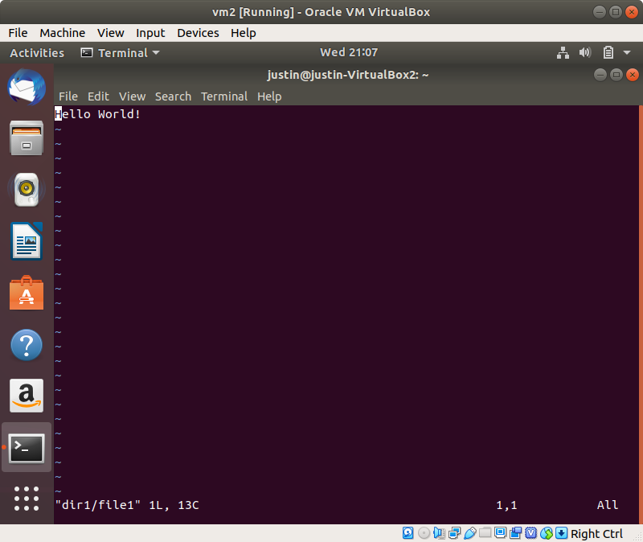

aa. chmod - change the permissions of a file

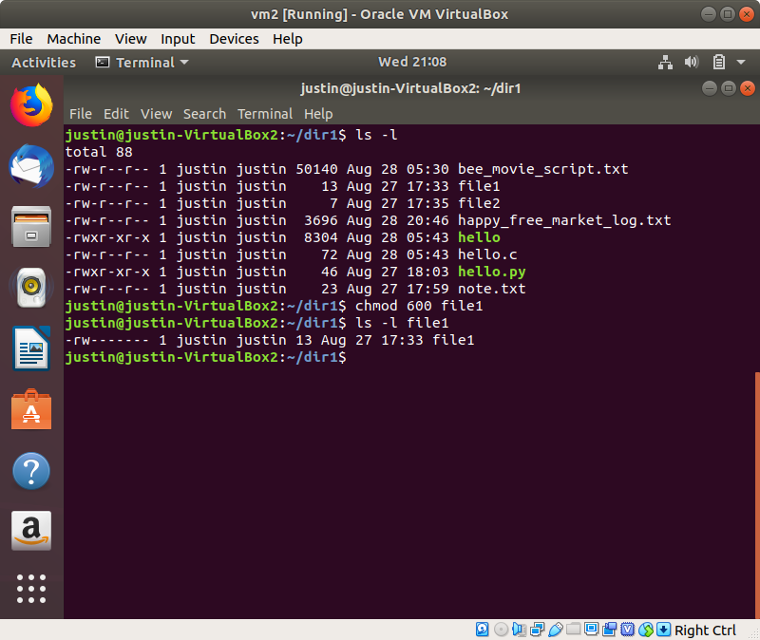bb. chown - change the owner of a file

cc. useradd - add a user to the system

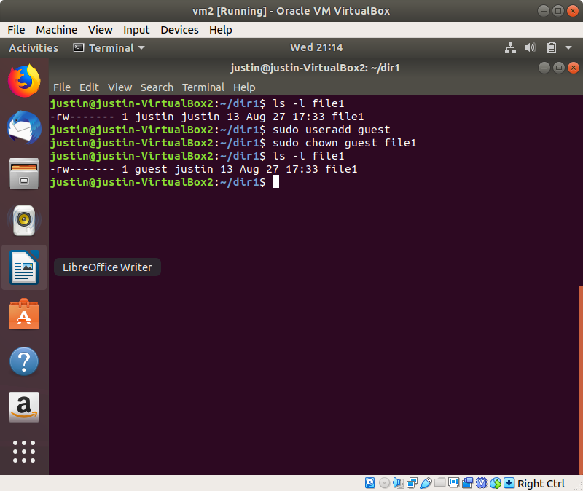

dd. man - show the manual of a command

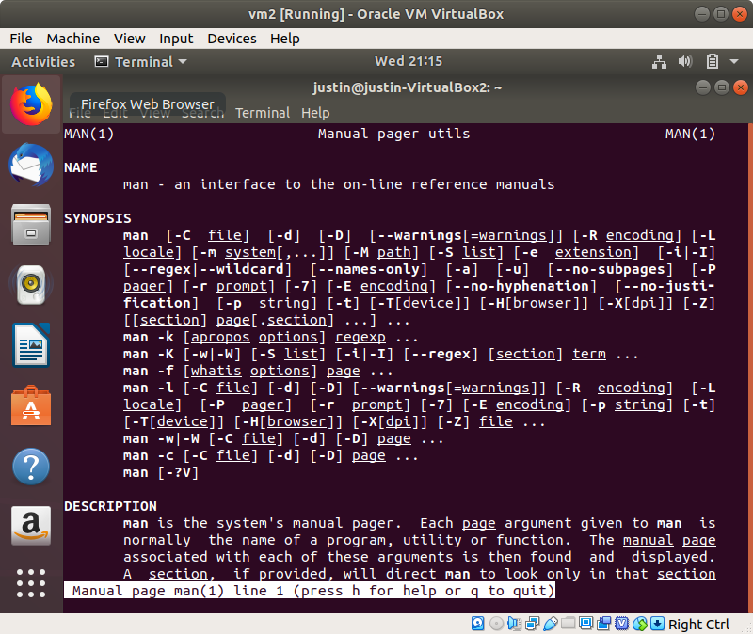

ee. locate - find a file by name, in the given directory

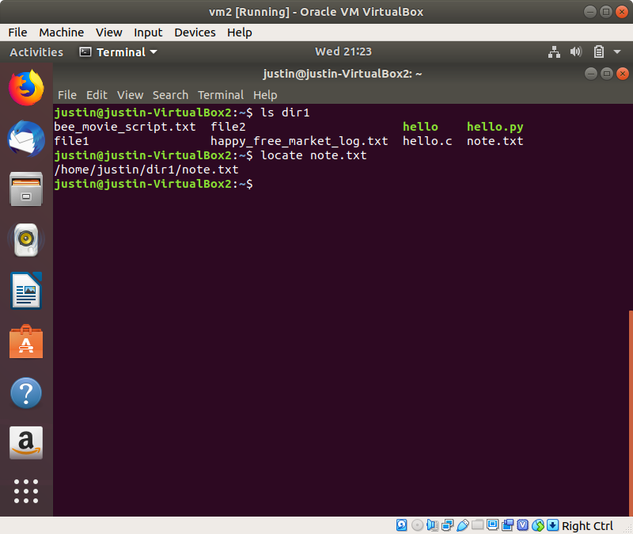

ff. find - find a file with the given filename, display all matches.

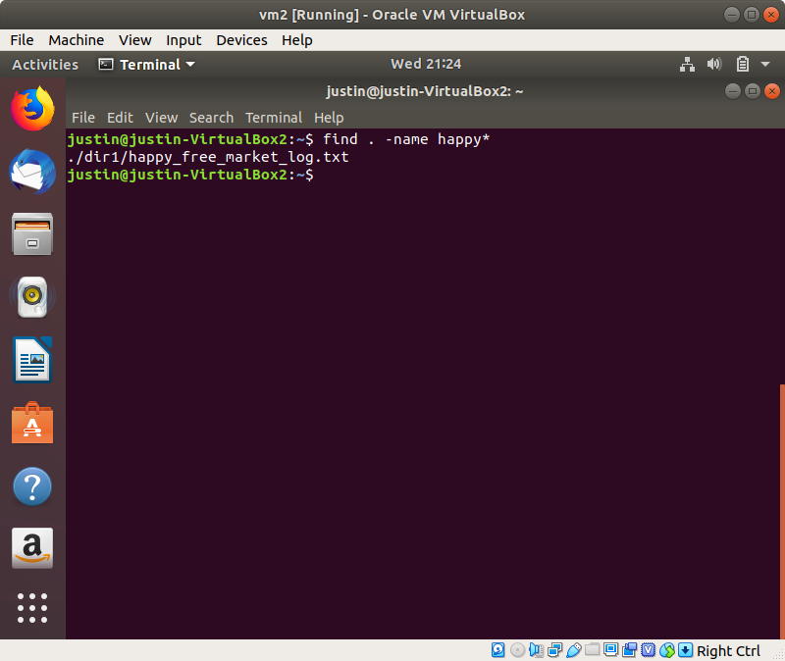

gg. sed - Match and replace text from a provided text stream

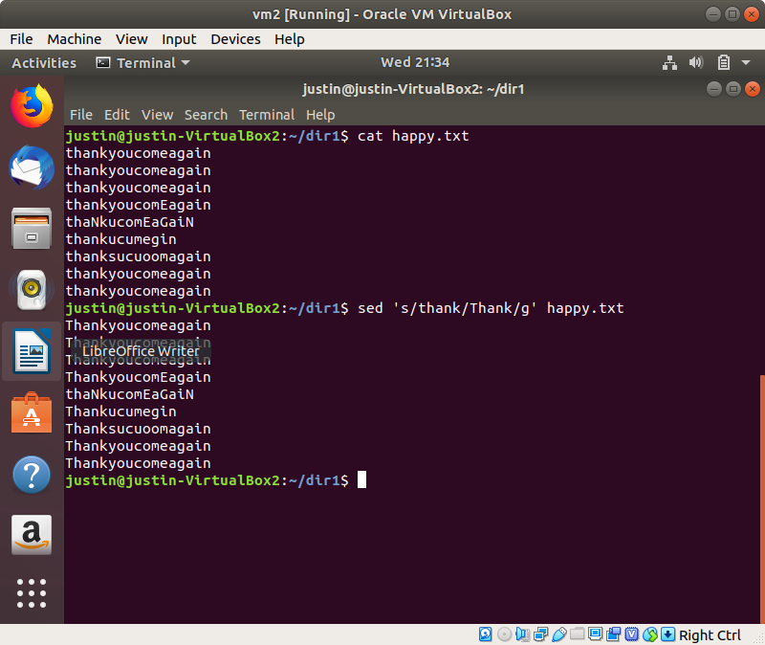

hh. awk - an interpreted programming language for text processing (matching, formatting, etc)

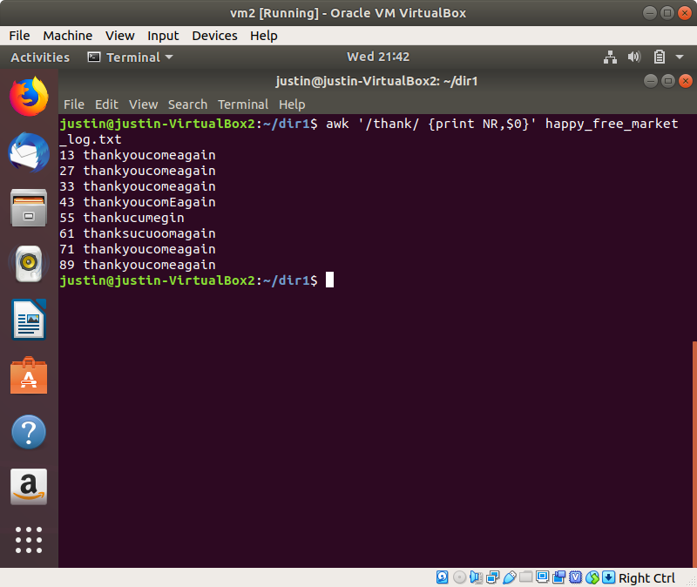

ii. diff - compare two files, line by line, and display the differences

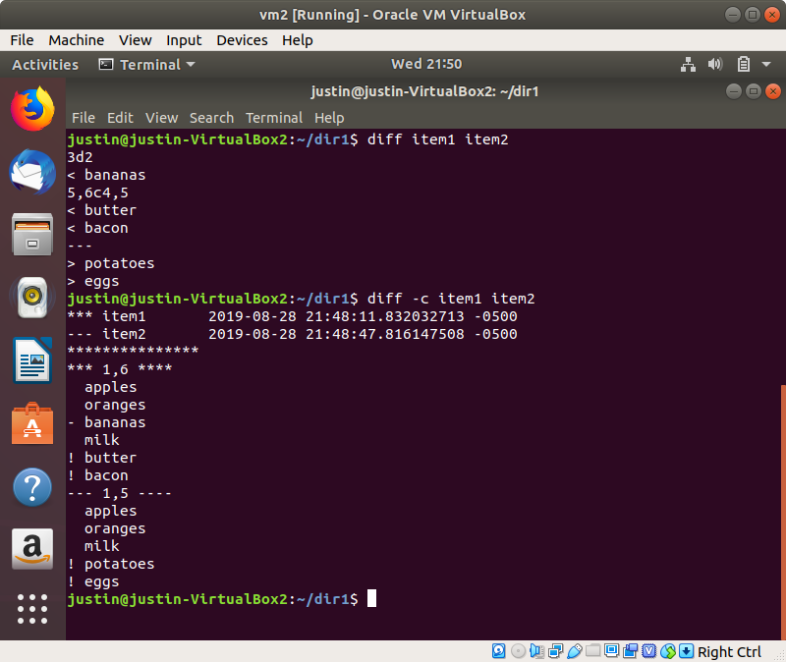

jj. sort - sort the file by line (alphabetically/numerically)

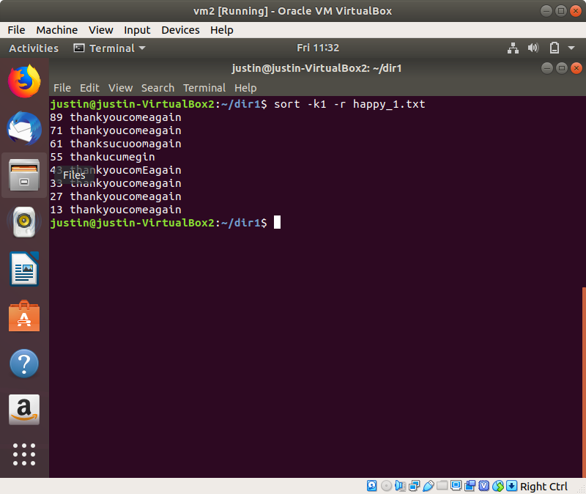

kk. export - Show all bash environment variables

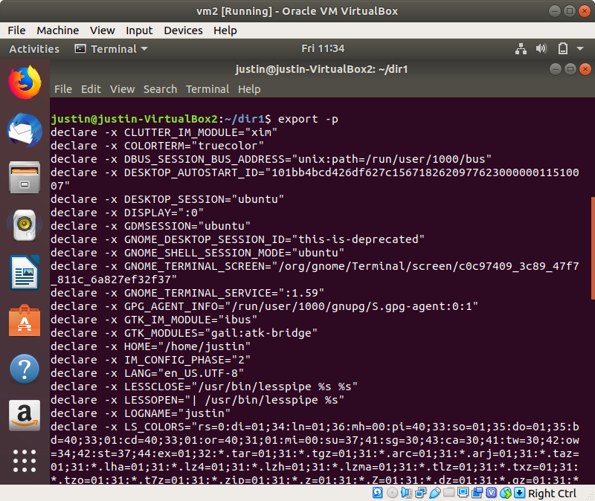

ll. pwd - print current working directory path

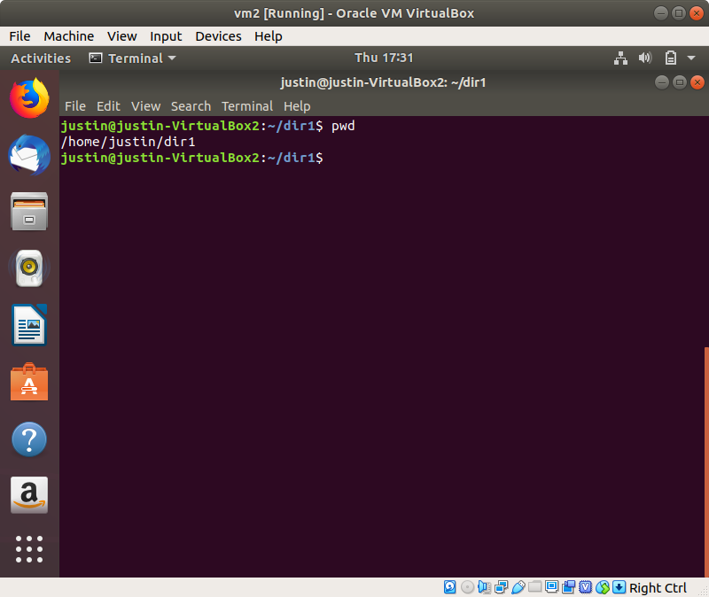

mm. crontab - schedule tasks to the cron daemon to run periodically.

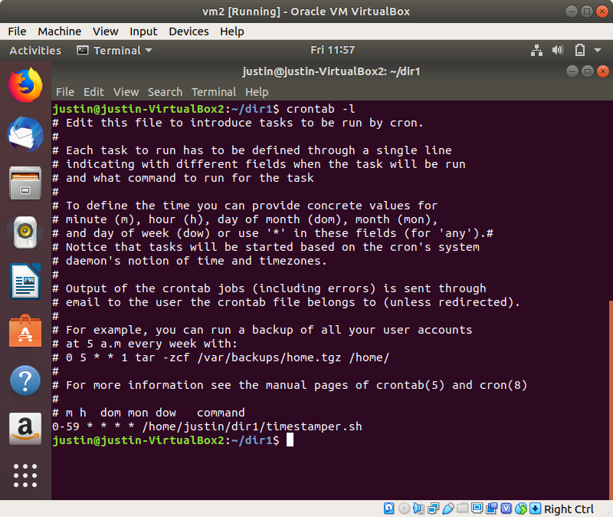

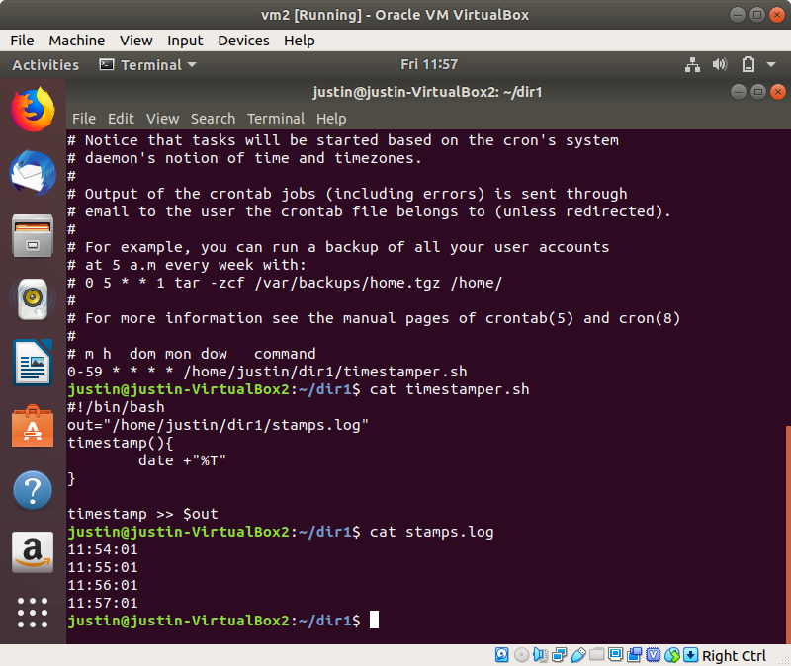

nn1. Create a disk in VirtualBox

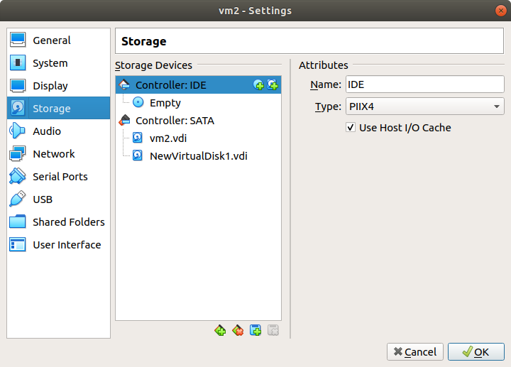

nn2. List the available devices with lsblk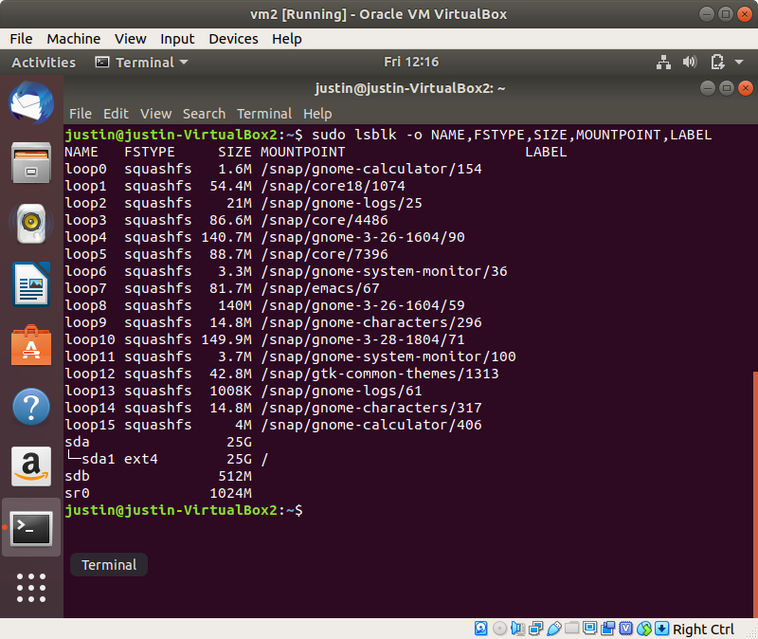

nn3. Create a new partition with fdisk

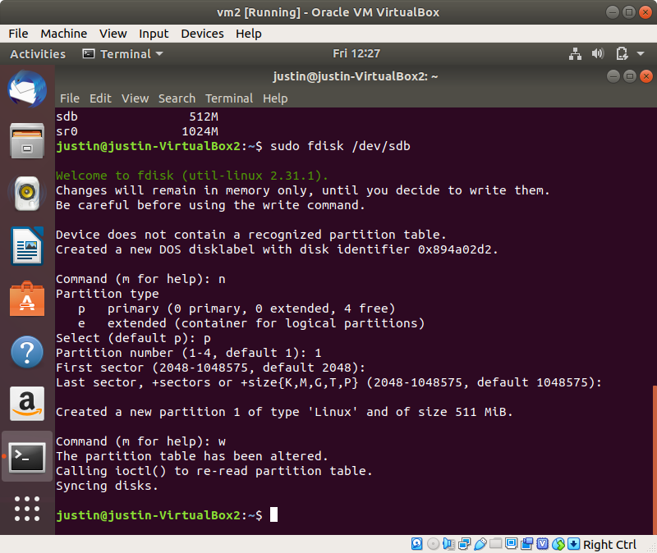

nn4. Mount the partition to the filesystem

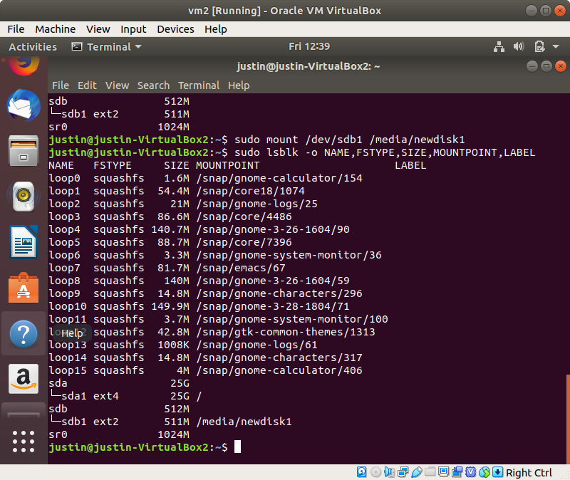

oo. passwd - change the password for a user

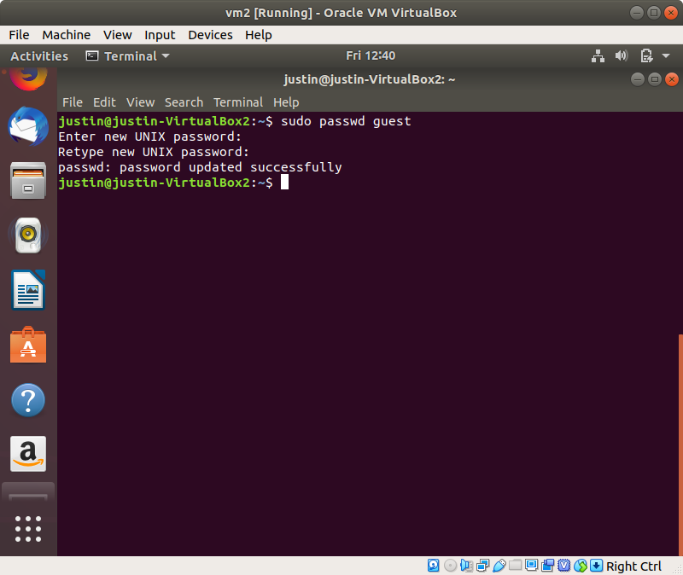

pp. uname - display system information of the current machine

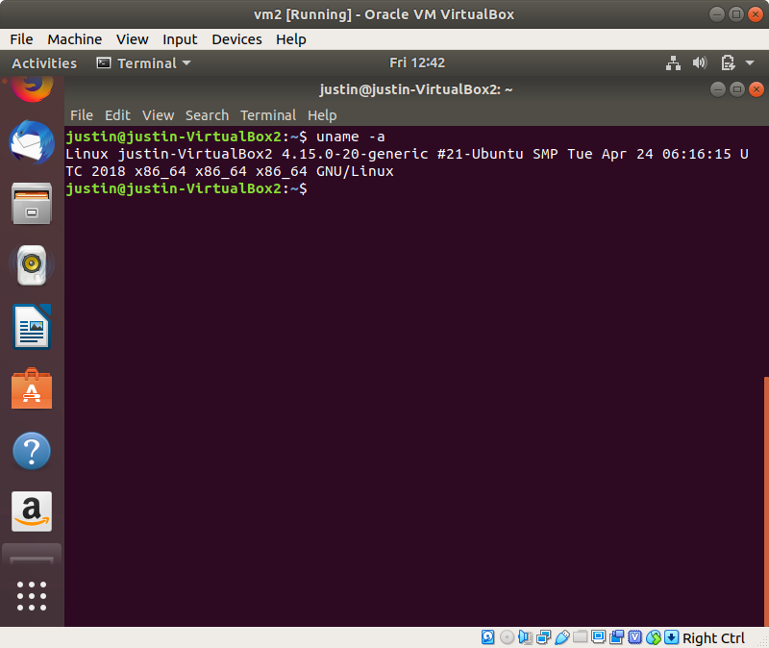

qq. whereis - Show the path of the executable of the given command

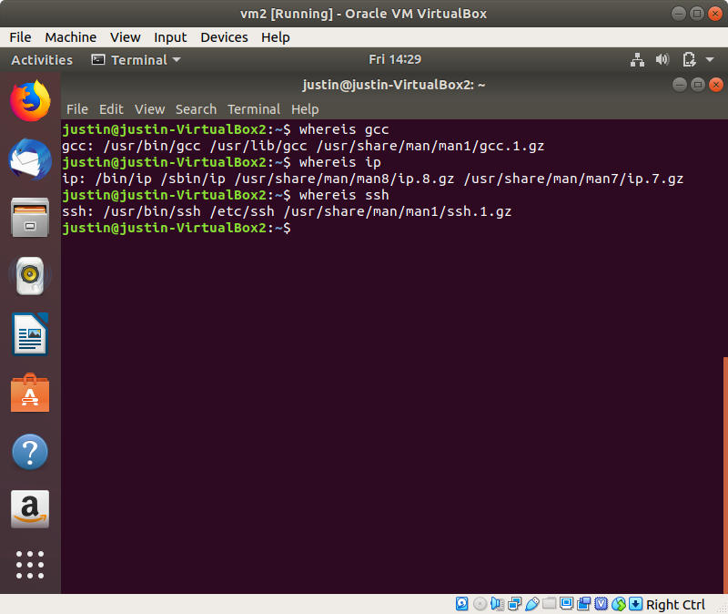

rr. whatis - Short description of the given command

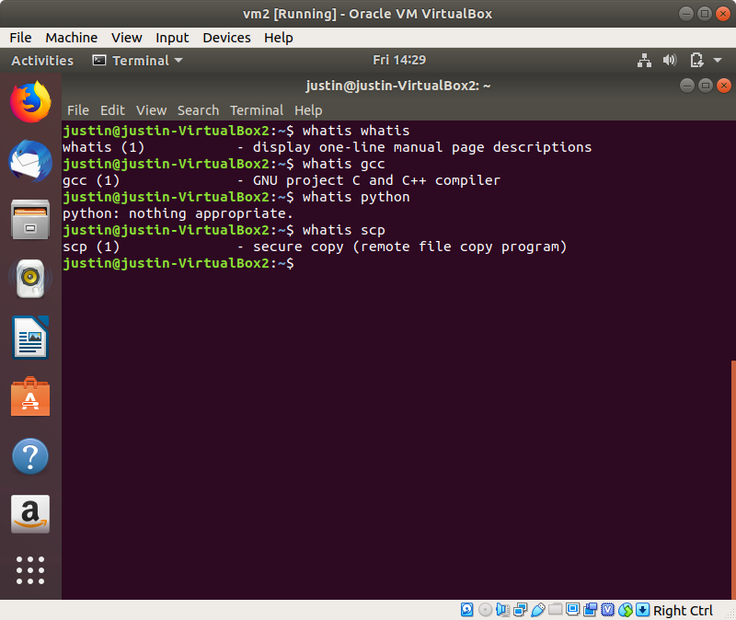

ss. su - Change the current user to another user in the system

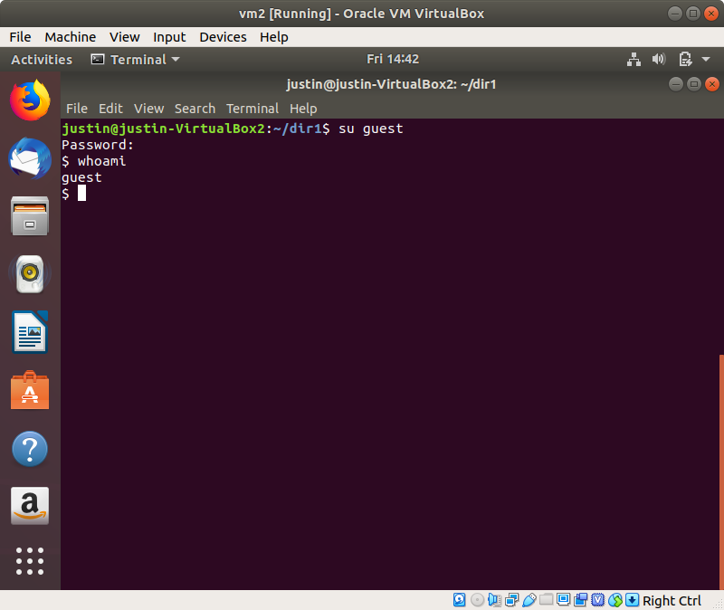

tt. ping - Ping a remote host, and show latency statistics

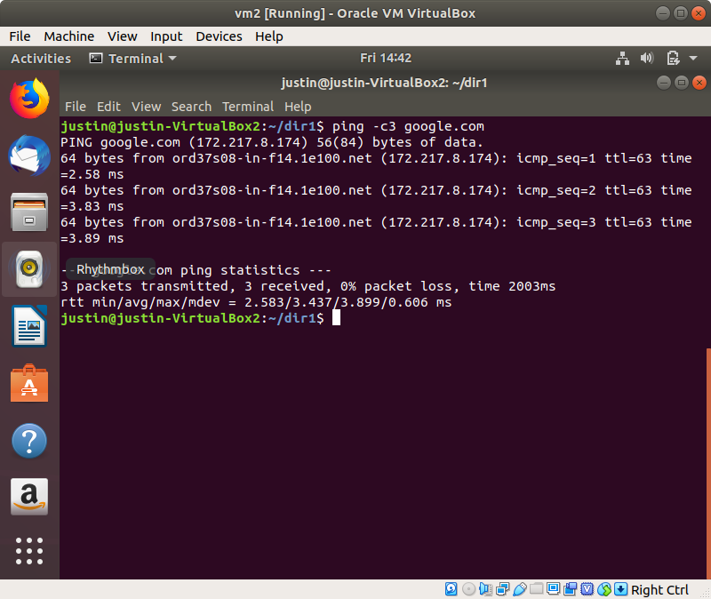

uu. traceroute - trace the routing of the sent packets

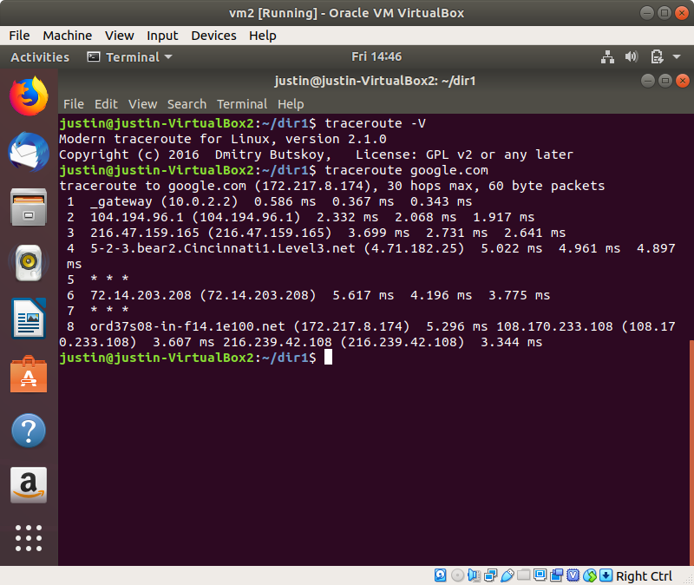

vv. date - display the current date and time of the system

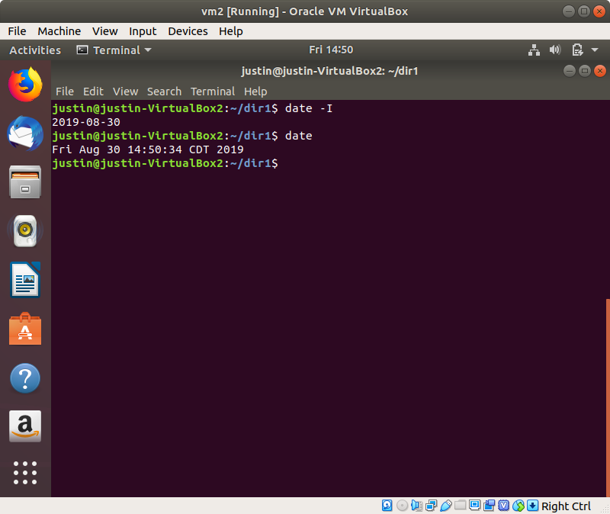

ww. time - show the execution time of a program (Real - start to finish, user - user-mode time, sys - kernel-mode time)

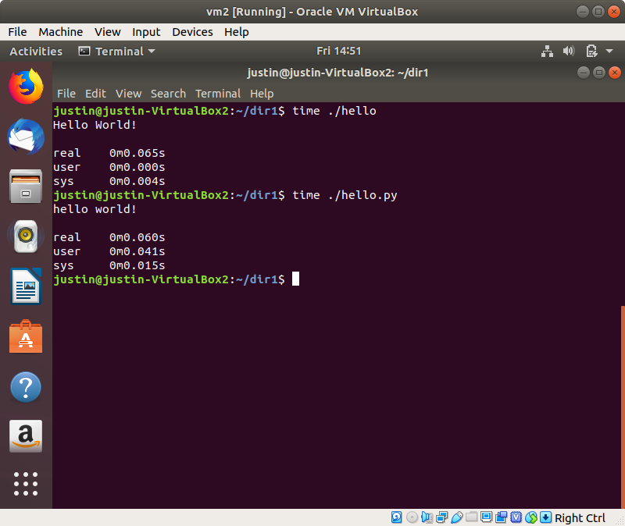

xx. wget - download a file using standard communication protocols (http, https, ftp)

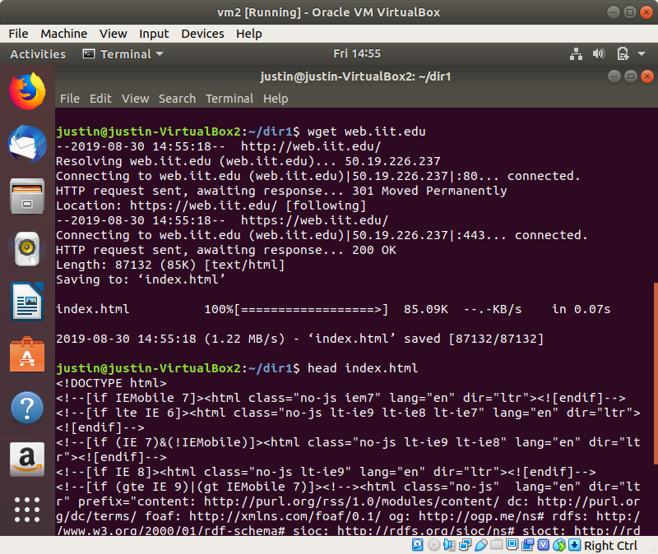

yy. wc - word count, counts the number of newlines, words, and bytes in a file

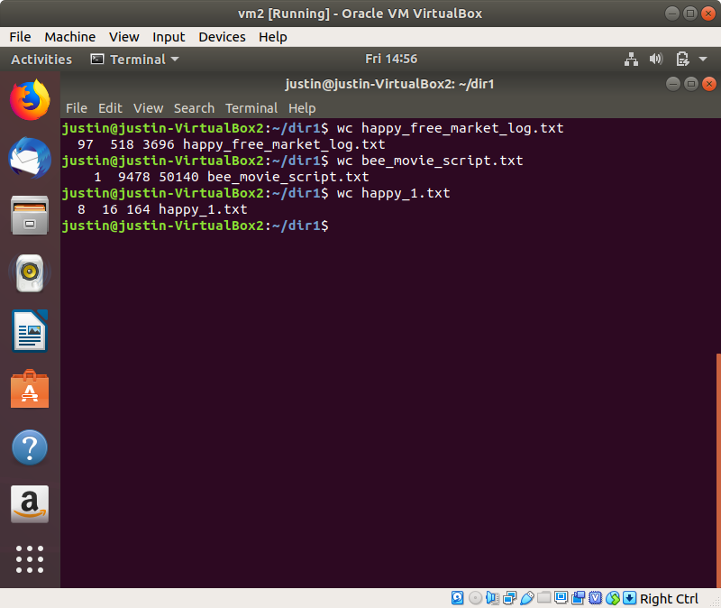

zz. pwgen - generate pronounceable passwords